**Special Events**

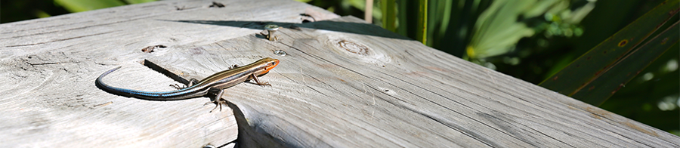There are three pavilions available for rent at Camp Salmen Nature Park. To rent one of these pavilions, call 985.867.5095 or 985.898.3011. To learn more about special events hosted by Camp Salmen, look no further than here. Download the rental agreement [here](http://www.campsalmennaturepark.org/Rental%20Information%20and%20Rules%20for%20Camp%20Salmen%20Pavilions%20%20Amphitheater.docx).

In addition to the venues below, we also have uncovered picnic tables scattered throughout the grounds.

|  |  |
| --- | --- |
| **Main Pavilion**  The main pavilion at Camp Salmen features ceiling fans, 8 picnic tables (2  are handicap accessible) and is adjacent to the playground. This pavilion is covered and has the park's only restrooms attached. | http://www.campsalmennaturepark.org/images/Pavilionlarge.jpg |
| **2 Small Pavilions (Lodge & Water Tower)**  These smaller pavilions are both located near large open, grassy areas. Both feature two picnic tables and are covered. The Lodge Pavilion also has a small bench. | http://www.campsalmennaturepark.org/images/Pavilion2.jpg |
| **Amphitheater**  The amphitheater at Camp Salmen is an ideal venue for small ceremonies —weddings, scouts, and awards. Set on the banks of Bayou Liberty, this intimate venue can hold up to 125 people and is a serene and picturesque location for various types of events for groups in smaller numbers. The amphitheater is also ADA compliant. | http://www.campsalmennaturepark.org/images/CampSalmen5.jpg |